**Week 3: Cloud Computing**

**Notes from lecture:**

Computing resources as a service, connected by the internet.

Useful because: Variable demand of computing resources . Hardware can break down, Software needs updating, Internet connection can be faulty, Physical security is not security.

**Notes from readings:**

Cloud Computing (V Rajaraman):

Definition: We define cloud computing as a method of availing computing resources from a provider, on demand, by a customer using a computer connected to a network (usually the Internet).

* No limit for contracting any computing resource.
* Can be accessed anywhere. Could be anywhere too.
* Resources are dynamically assigned and automatically optimize balance supply and demand

Services available:

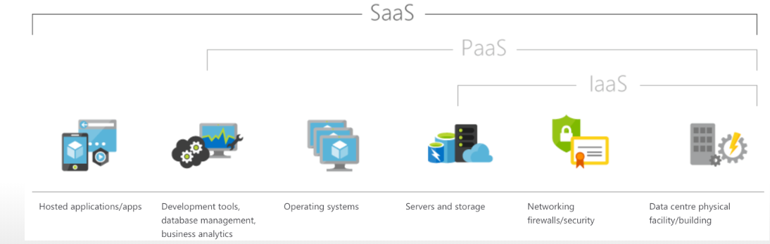

* **Software as a Service (SaaS)** In this case a software vendor creates application software which runs on the infrastructure installed by an IaaS provider or on servers maintained by the application vendor which are connected to the Internet:
  + **Gmail, Google drive, Dropbox, Google docs…**
* **Platform as a Service (PaaS):** This service is built over IaaS. In this type of service the provider maintains, besides the hardware infrastructure, software infrastructure such as an operating system, programming languages, and application program development and deployment tools.
  + **AppEngine, You can have any platform preconfigured.**
* **Infrastructure as a service (IaaS):** provider mantains computer servers, storage servers, and communication infrastructure, that is, data centre services. As different customers may deploy their own operating systems and applications running on them, the servers are enveloped by a layer of software which makes them behave like the hardware system demanded by the user. This is called virtualization.
  + **AWS, Amazon EC2, Google Cloud, Azure**

**Cloud and IoT**: All the process of information from IoT is sent to the cloud and this creates A LOT of information that was before impossible to use. For example healthcare information recorded by Apple Watch.

**USES:**

PaaS: Data storage, Computaion, Data adquisition.

**Types of cloud:** They are differentiated based on the way they are deployed and access provided to them. We list below four types of clouds:

1. Public Cloud: The computing infrastructure maintained by a provider is available to anyone. It is located usually in the provider’s premises and controlled by the provider. (Gmail, Gdocs, Amazon EC2)
2. Private Cloud: The computing infrastructure is available for the exclusive use of a single organization. It may be a physically distributed set of interconnected computing systems belonging to the organization accessible to its members from anywhere, for example, from the far-flung branches of the organization. (Banks)
3. Community Cloud: The computing infrastructure is available for the exclusive use of a specific community of users with shared interests. For example, a group of universities may decide to cooperate and interconnect their computing infrastructure and create a community cloud which may be accessed by any of its members (Universities)
4. Hybrid Cloud: The computing infrastructure is a combination of two or more distinct entities, namely, private cloud, public cloud or community cloud. Each entity remains distinct but they are bound together by standardized protocols that permit data and application portability. For example, an organization may decide to keep part of its applications which it considers sensitive in its private cloud and execute other less sensitive applications on a public cloud.

**Tecnological trends:** From owning computers to having access to software and hardware maintainded by providers (like Netflix). Cloud computing has become a reality due to three independent factors. They are: rapid growth of computer and communication technologies, changes in management philosophy, and the availability of excess computing capacities with giant corporations such as Amazon and Google.

* Serverless computing: You go directly to the uses (program/db) without configuring the server. (Server computing: Configure all parts of the mechanism (server) to include all the parts of a “web app” (program/database)
  + **Adventages:** Good for rea time/scalable, cheaper
  + **Disadvantages:** new idea, Not for memory intensive tasks, Not for things that take too much time.
  + **Examples:** **AWS Lambda, Google functions, Azure Functions**

**What has allowed this?** High badwith, storange, cpu, OS with multiple users and virtualization. Management philosophy with costs of software and hardware (licences and obsolocence).

**Advantages**:

Reduction in capital expense of organizations as they need not invest in large computer infrastructure and repeatedly invest as computers become obsolete.

* **Availability** of a host of software systems on a ‘pay for what you use’ basis.
* **Elastic and scalable** computing infrastructure available ‘ondemand’. An organization can request more computing power as and when it is needed with an illusion of infinite availability of processor power and storage. This facility is a great advantage for ‘start-up’ companies which need not unnecessarily invest in huge infrastructure. As and when their business expands they can request more computing power from a provider and pay only for what they use.
* **Assured Quality of Service** based on Service Level Agreements (SLA) which organizations can sign with providers.
* **Data security:** Organizations can use a cloud infrastructure to automatically back up their important data. This will allow quick recovery if data is corrupted. Organizations can archive data which they require occasionally for legal purposes on cloud storage.
* But you need safe comuncation and application

Disadvantages:

* Cost?
  + Some of the costs are availability, do you really need this availability?
* Comunication: you need a **reliable** and **secure** connection.
  + Using a cloud crucially depends on un-interrupted communication with the cloud provider’s infrastructure. **Failure of communication will cut off a cloud service**
  + Whenever data or program is sent on a publicly accessible communication system and data is stored in a shared disk system there is a danger of eavesdroppers tapping the communication line and stealing or corrupting data or stealing it from disk storage. To mitigate this, it is essential to use strong encryption of all data sent to the cloud on a communication system and also encrypt data before storing.
* Legal compliance:
  + Complex legal problems may arise if providers’ servers are in a foreign country and an organization’s programs and data are corrupted or stolen. An organization must clarify what laws apply while signing the Service Level Agreement with a cloud services provider.
  + A recent problem is the clandestine surveillance of data traffic on the Internet by the intelligence agencies of USA. and UK.
* Another risk is the deterioration of the quality of service of a cloud provider or a provider ceasing operations due to bankruptcy.

Appropiate applications:

* Routine operations such as payroll processing, order processing, sales analysis, etc.
* Hosting websites of organizations. Traffic to such websites is unpredictable and there may be surges in demand which is handled better by a cloud provider as the provider is better equipped to provision not only more computing resources on demand but also larger bandwidth to access the websites.
* Those which require high performance computing or specialized software not available in the organization. For example, an engineering company may have a specialized design problem which may require a high performance computer or a special application software package.
* Parallel computing, particularly tasks in which a program is executed in a large number of processors concurrently with multiple data sets to speed up computation. An example is to find the websites in which a specified set of keywords occur. The universe of websites may be partitioned into, say 1000 sets.

**Conclusions:**

Cloud computing is here to stay. Some professionals consider it is as the biggest development of the decade in computing. Every organization including educational institutions should have a cloud strategy on how to make best use of this new facility. As we pointed out, using a cloud computing facility crucially depends on the availability of broadband communication. Broadband communication infrastructure spanning the entire country is vital if this technology is to be used widely. T